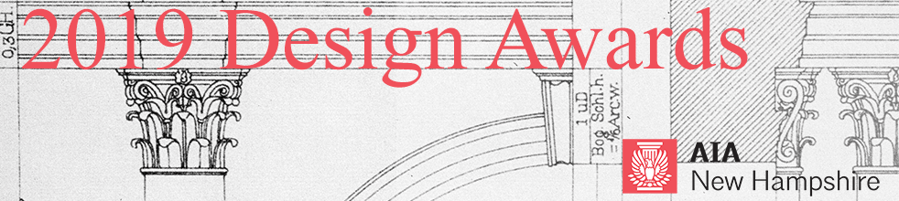
CALL FOR ENTRIES – 2019 Rick & Duffy Monahon Award for Design Excellence in Architectural Restoration and Preservation

This award was established in 2014 in honor of Rick and Duffy Monahon as a way to recognize their extraordinary contribution to architecture and preservation in New Hampshire. The award promotes outstanding and exemplary historic preservation projects as defined by their sensitivity to an historic structure and its surrounding environment; the quality of architecture, workmanship, and materials; as well as the degree of challenge or accomplishment and the level of community support for the project.

SUBMISSION SUPPORT
All submissions will be received via Submittable, an online portal: https://aianewhampshire.submittable.com/submit
It is recommended to use Chrome or Firefox browsers for submissions made through Submittable.
If you encounter technical difficulty with your awards submission, please contact: Submittable Tech Support at: (855) 467-8264, ext. 2 or support@submittable.com. Non-technical questions about awards can be addressed to: Bonnie Kastel, bkastel@aianh.org.

SUBMISSION DEADLINE
February 22, 2019, 5 PM
All submissions must be complete by this date. Your submission will be received by AIANH after payment has been made. If your submission fee has not been paid, AIANH will not see or have any record of your submission. Payment is the last step of the submission process. Once your submission fee is paid, your submission cannot be edited. Prior to that point, drafts may be saved to your Submittable account and modifications made.
You may submit multiple projects to this awards program. Each project must be submitted and paid for separately. If you submit multiple projects, remember to select the discounted, subsequent entry fee after the first entry.

NOTIFICATION OF AWARDS
Submitters will be notified after March 8 and awards will be conferred on Thursday, March 28, 2019 at the AIA New Hampshire Awards Banquet at the Currier Museum of Art in Manchester, NH. Registration for the Awards Banquet will open in February.

ELIGIBILITY
- Architects who submit must be members of AIA New Hampshire.
- Projects must be located in New Hampshire.
- Firms domiciled outside NH may only submit projects located in NH. One principal from the firm must be a member of AIANH. If you are not currently a member, complete the AIANH Component Allied Membership form and send it with payment to the AIANH office: bkastel@aianh.org.
The following project types are eligible:
- Sensitive Addition/Alteration: a project that successfully integrates an addition/alteration within the architectural style of a building and complements the context and character of an historic district, neighborhood, or specific area.
- Adaptive Reuse: a project that creatively achieved the reuse of an existing structure originally used for another purpose. The project must have undertaken at least substantial rehabilitation.
- Appropriate New Construction: a new structure that, through its design and use of building materials, enhances the quality of the built environment. The project must have a positive impact on its immediate surroundings, including historic district, neighborhood or specific area.
- Innovative Solutions in Preservation: Showing sensitive and creative solutions incorporating issues of sustainability, adaptive reuse and integration of accessibility improvements.
The Secretary of the Interior’s Standards for Rehabilitation and the Guidelines for Rehabilitating Historic Buildings will be considered in evaluation for this award.
Only one project will receive this award in a given year. The jury may elect to not present this award to any of the submissions in this category.

CRITERIA
The jurors’ decisions will be based on the materials submitted.

FEES
First project entry: $220 ($160 + $60 for presentation board production)
Additional project entries: $185 ($125 + $60 for presentation board production)
Each project submission requires a presentation board that will be used for display during the Awards Banquet and, thereafter, on tour throughout New Hampshire during 2018.
All fees are not refundable and must be paid online via credit card at time of submission. Submissions cannot be received and marked complete until payment is made.

SUBMISSION REQUIREMENTS
All submissions for the 2019 AIA New Hampshire Design Awards must be digital and submitted by Friday, February 22, 2019, 5 PM. No binders will be accepted. The decisions of the jurors will be based solely on the materials submitted.

Project Information (as possible)
- Project Name
- Project Category
- Project Location
- Completion Date
- Architecture or A/E Firm Name
- Architect of Record
- Design Architect
- Project Team
- General Contractor
- Project Consultants
- Client
- Client Permission
- Project narrative: A brief, 400 word or less, description of the project.
- Do not include any identification of entrant or project team in the project narrative section.
- The jurors have a limited time with each submission. Please format text accordingly.
- Photo credits
- Presentation Board: This board is used for publicity purposes. It will be on display at the Awards Banquet in March. Thereafter, it will be on exhibit at various locations around New Hampshire. This year we plan to use a layout template to standardize the overall board design. This project is nearly complete. Information about the presentation boards will be available shortly on Submittable.
- Publicity Description: A brief, 150 word or less, description of the project that will be used for promotional purposes. Unlike the Project Narrative, you may include identifying information about your firm, project and client.
- Submitters must agree to the 2019 AIA NH Permission Form for Textual and Visual Works provided on the online submission form.
Digital Slides
Please note: Submissions will be reviewed by jurors on a computer and/or projection screen. Slides should be legible when printed at 8.5”x11”
- Submissions must include no more than twelve (12) digital slides arranged in the order you wish them viewed. Start each file name with its order number (ie. 1_front facade.jpg, 2_rear elevation.jpg).
- Each digital slide must be 2MB or less, in jpg format.
- A composition of drawings, images, and other illustrations may constitute one (1) digital slide.
- Do not include any identification of entrant or project team in the digital slide section.
- Do not include project narrative in the digital slide section.
- Submitters may be asked to provide high-resolution imagery for publication after judging is complete.

JURORS
The jury for the 2019 AIANH Design Awards will be composed of professional colleagues from the state of Rhode Island.

FREQUENTLY ASKED QUESTIONS:
Do I have to start and finish my submission in one session?
No. You can start your submission and return to finish it before the deadline date. To do so, scroll to bottom of submission page and click “Save Draft” button.
Can I make multiple entries?
Yes. However, you must submit your first entry before starting on a new entry.
What if I want to make changes to my entry after I have completed my submission?
Once you click “Submit” you will need to contact bkastel@aianh.org to make edits.
ADDITIONAL QUESTIONS:
Additional questions should be directed to Bonnie Kastel, AIA New Hampshire Executive Director, at bkastel@aianh.org or 603.501.1881.

